

**“IR AUDIO TRANSMITTER & RECIVER”**

**A MINI PROJECT**

**REPORT**

*Submitted by*

**G VISHNU VARDHAN (1NH18EC035)**

**G MANOJ REDDY (1NH18EC144)**

**G BHAVADEEP REDDY (1NH18EC034)**

**K HAMENTH (1NH18EC050)**

***In partial fulfillment for the award of the degree of***

**BACHELOR OF ENGINEERING**

IN

**ELECTRONICS AND COMMUNICATION**

**ENGINERRING**



**DEPARTMENT OF ELECTRONICS AND COMMUNICATION ENGINEERING**

# CERTIFICATE

Certified that the mini project work entitled“**IR AUDIO TRANSMITTER & RECIVER**” carried out by **G VISHNU VARDHAN (1NH18EC034), G MANOJ REDDY (1NH18EC144), G BHAVADEEP REDDY (1NH18EC034), K HAMENTH (1NH18EC050),** bonafide students of Electronics and Communication Department, New Horizon College of Engineering, Bangalore.

The mini project report has been approved as it satisfies the academic requirements in respect of mini project work prescribed for the said degree.

Ms. ISHANI MISHRA

Project Guide HOD ECE

------------------------- -------------------------

**External Viva**

Name of Examiner Signature with Date

1.

2.

**VISVESVARAYA TECHNOLOGICAL UNIVERSITY**

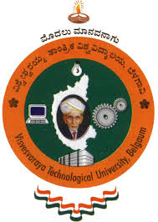

MINI PROJECT REPORT ON

**“IR AUDIO TRANSMITTER & RECIVER”**

SUBMITTED BY:

**G VISHNU VARDHAN - 1NH18EC035**

**G MANOJ REDDY - 1NH18EC144**

**G.BHAVADEEP REDDY – 1NH18EC034**

**K HAMENTH – 1NH18EC050**

Under the guidance of

**Mrs.ISHANI MISHRA**

Senior Assistant Professor,

Dept. of ECE, NHCE, Bengaluru.

# C:\Documents and Settings\Students\Local Settings\Temporary Internet Files\Content.Word\download (1).jpg

# NEW HORIZON COLLEGE OF ENGINEERING

(ISO-9001:2000 certified, Accredited by NAAC ‘A’, Autonomous college permanently affiliated to VTU)Outer Ring Road, Panathur Post, Near Marathalli, Bengaluru-560103

## NEW HORIZON COLLEGE OF ENGINEERING

## DEPARTMENT OF ELECTRONICS AND COMMUNICATION ENGINEERING



**CERTIFICATE**

Certified that the miniproject work entitled “**IR AUDIO TRANSMITTER & RECIVER**” carried out by **G VISHNU VARDHAN (1NH18EC034), G MANOJ REDDY (1NH18EC144), G BHAVADEEP REDDY (1NH18EC034), K HAMENTH (1NH18EC050**bonafide students of Electronics and Communication Department , New Horizon College of Engineering, Bangalore.

The mini project report has been approved as it satisfies the academic requirements in respect of mini project work prescribed for the said degree.

Project Guide HOD ECE

------------------------- -------------------------

**External Viva**

Name of Examiner Signature with Date

1.

2.

**ACKNOWLEDGEMENT**

The satisfaction that accompany the successful completion of any task would be, but impossible without the mention of the people who made it possible, whose constant guidance and encouragement helped us succeed.

We thank **Dr. Mohan Manghnani**, Chairman of **New Horizon Educational Institution**, for providing necessary infrastructure and creating good environment.

We also record here the constant encouragement and facilities extended to us by **Dr.Manjunatha**, Principal, NHCE and **Dr. Sanjeev Sharma**, head of the department of Electronics and Communication Engineering. We extend sincere gratitude to them.

We sincerely acknowledge the encouragement, timely help and guidance to us by our beloved guide **Mrs.Ishani mishra** to complete the project within stipulated time successfully.

Finally, a note of thanks to the teaching and non-teaching staff of electronics and communication department for their co-operation extended to us, who helped us directly or indirectly in this successful completion of mini project.

**G VISHNU VARDHAN - 1NH18EC035**

**G MANOJ REDDY - 1NH18EC144**

**G.BHAVADEEP REDDY – 1NH18EC034**

**K HAMENTH – 1NH18EC050**

**LIST OF FIGURES**

|  |  |  |
| --- | --- | --- |
| **FIGURE**  **No** | **FIGURE DESCRIPTION** | **Page**  **No** |
| 1 | Circuit diagram | 14 |
| 2 | LM386 | 17 |
| 3 | BC548 Transistor | 25 |
| 4 | Photo Diode | 28 |
| 5 | capacitors | 29 |
| 6 | Breadboard | 32 |
| 7 | Battery | 29 |
| 8 | Pot | 32 |

### LIST OF TABLES

|  |  |  |  |
| --- | --- | --- | --- |
| **SL**  **No** | **Table**  **No** | **TABLE DESCRIPTION** | **Page**  **No** |
| 1 | 1 | Components | 14 |
| 2 | 2 | Problems | 14 |

**ABSTRACT**

**IR AUDIO TRANSMITTER AND RECIVER In this project, We will explain how to design a simple IR audio link circuit that will transmit audio signals wirelessly. This IR audio connection can transmit audio signals over short distances. The audio signal to be transmitted is applied to the base of the transistor in the emitter section. A speaker 8 or headphones is connected to the receiver section to hear the transmitted signal. Infrared is the most commonly used wireless medium for a limited range, and we've already covered the simple IR transmitter and receiver circuitry. In this abstract today, we will learn how to create a raw wireless audio transmission circuit using IR LEDs. With this circuit we should be able to play songs from our iPod, mobile phone or computer on an external speaker without having to connect them directly with an AUX cable. The circuit has many limitations and there are better options like Bluetooth to play songs wirelessly. This abstract is only intended to help you understand simple audio circuits while having fun playing them. to build. In addition, the circuitry for this project is simplified as much as possible to keep things simple and reliable and to simplify construction. So this should be a great weekend project to build and study with our friends.**

**CHAPTER 1**

**INTRODUCTION**

**Wireless audio is already a technically advanced field in which Bluetooth and RF communication are the main technologies (although most commercial audio devices use Bluetooth). Designing a simple IR audio connection circuit would not be advantageous over existing technologies, but it will certainly be a learning experience in wireless audio transmission.**

**The reason that IR is not advantageous is that, unlike Bluetooth, IR is a line of sight, ie the transmitter and receiver must always face each other without obstacles. In addition, the range may not be as great as that of a typical wireless Bluetooth audio.**

**CHAPTER 2**

**LITERATURE SURVEY**

1. **IR TRANSMITTER AND RECIVER USING NE555**

**The most common use of infrared communication (IR) is to remote control various devices such as televisions. The handheld remote control for the television consists of an infrared transmitter and the infrared receiver is attached to the television.**

**Some integrated projects also consist of IR transmitter and receiver modules, in which they can be used as proximity sensors or distance sensors.**

**In this project we demonstrated how a simple infrared transmitter and receiver works with the 555 timer.**

**The aim of the project is to explain how infrared (IR) communication works with simple hardware. For this project, we used the TSOP 1738 IR receiver to receive infrared signals and a simple IR LED to send infrared signals. The circuit diagram, the components and the mode of operation are explained in the following sections.**

**The circuit is build using the following components:**

**1.TSOP 1738 IR RECIVER:**

**TSOP 1738 is an IR receiver for IR remote controls (infrared). It consists of a photodetector, a gain control, a bandpass filter, a demodulator and a preamplifier in a single housing. The IR receivers of the TSOP17XX series are very common for all types of transmission codes that support different modulation techniques such as RC6, RC5, NEC, Sony etc.The TSOP 1738 supports in particular a carrier frequency of 38 kHz and the output of this IR receiver can be connected directly to a microcontroller or a microprocessor. TSOP 1738 has three pins, namely GND, VS and OUT. The following picture shows the pin for TSOP 1738.**

**TRANSMITTER CIRCUIT**

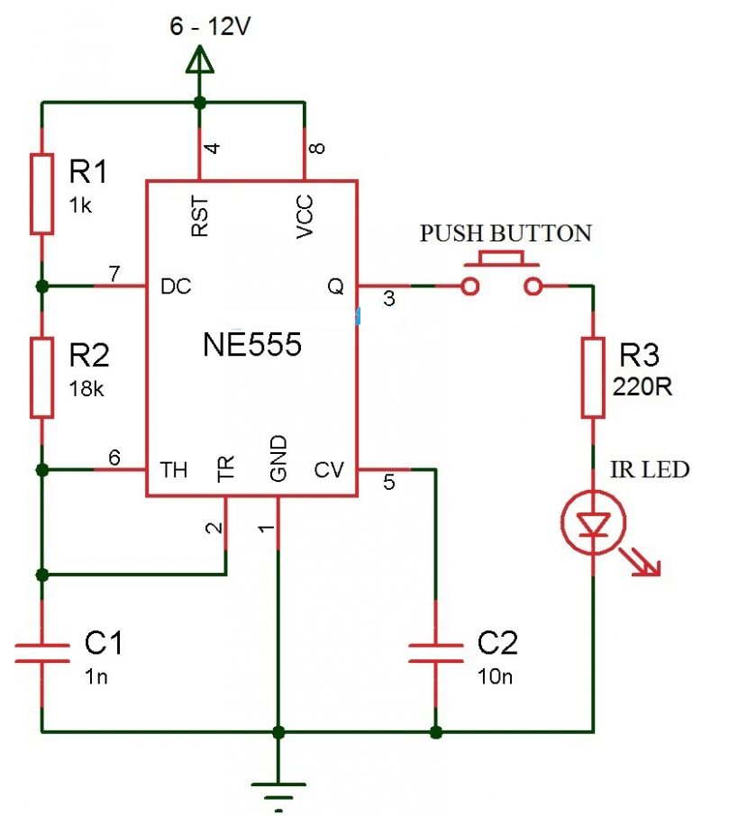



**RECEIVER CIRCUIT**

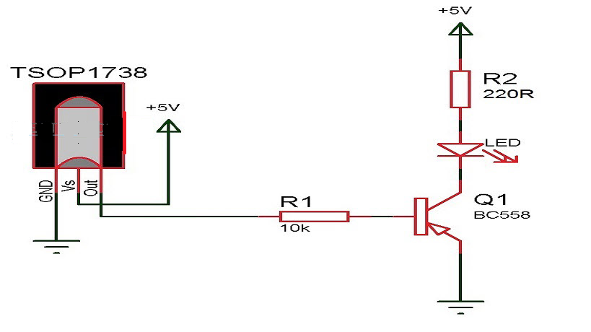

**The circuit which shown above is very complecated.**

**2.IR TRANSMITTER AND RECEIVER USING MICROCONTROLLER**

**IR transmitter (encoder) with NEC protocol using the CCS-PIC-C code PIC12F1822: This is the complete code for the microcontroller of the NEC-IR transmitter. There are 5 push buttons in the circuit and each button sends a different IR signal code. The IR transmitter is the element that sends the IR signals to the IR receiver circuit.**

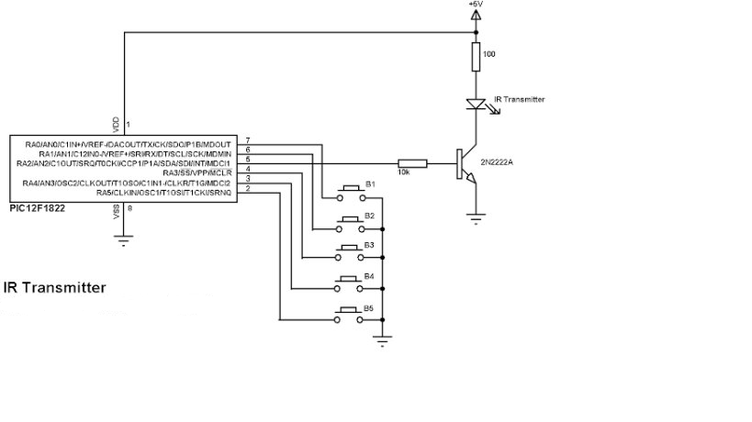Rawjgw;rojgn;RH

**CHAPTER 3**

**PROPOSED METHODOLOGY**

**In this project, the LM386 audio amplifier acts as the heart of the project. The LM386 is the sole controller for the power supply to all the components in the circuit. The LM386 is powered through a 9V battery. If an infrared remote control is used on the IR receiver, the device translates the signal and transmits it via HF. The paired unit then receives this signal, decodes it and sends an IR signal. IR transmitters and receivers can also be used with some computers.When the audio signal is given to the transmitter then the photodiode of the transmitter genrates the signals to the LM386 audio amplifier than the signal get amplified and genrates the output from the speaker**

**Fig 1**

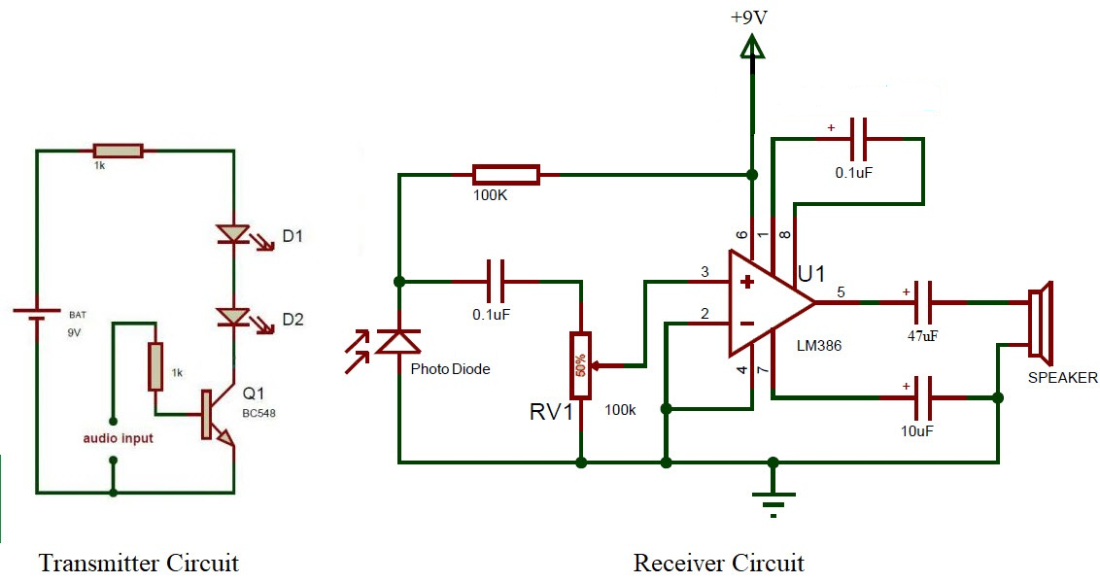

**CHAPTER 3.1**

**COMPONENTS REQUIRED**

|  |  |  |  |
| --- | --- | --- | --- |
| S.No. | Required Components | Remarks | Quantity |
| 1 | Amplifier | Lm386 | 1 |
| 2 | Transistor | BC548 NPN transistor | 1 |
| 3 | Breadboard |  | 2 |
| 4 | Photo diode |  | 1 |
| 5 | Resistor | Quarter watt | 1k ohm - 2  100k Ohm – 1 |
| 6 | Capacitor | Ceramic | 0.1uf – 2  10uf 1  47uf - 1 |
| 7 | Ir transmitter | LEDs | 2 |
| 8 | Speaker | 9ohms | 1 |
| 9 | Battery | 9v | 1 |

**CHAPTER 4**

**PROJECT DESCRIPTION**

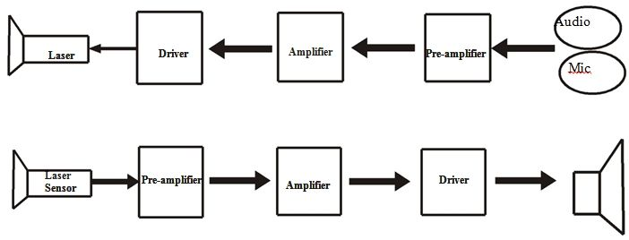

**The IR audio connection circuit is divided into two parts: one is the transmitter section and the other is the receiver section. The transmitter part works with a 9V battery. Here the audio signal input is applied to the base of the Q1 via a 1KΩ resistor.Here, the transistor Q1 is used to drive the IR LEDs D1 and D2. The input audio signal is modulated into transmitted infrared signals.The transmitted infrared signals are received by the photodiode. The audio signal is now converted into an electrical signal and then transmitted to LM386.The LM386 is a simple audio power amplifier IC with a maximum output power of approximately 1 W. It can drive 4Ω and 8Ω speakers, and in this circuit I used an 8Ω mini speaker.**

**In this circuit I used 9V batteries to power the transmitter and receiver sections. Instead of the photo diode, you can also use a photo transistor such as BPW77NA, BPW85, PNA1605F or PNZ154 in the receiver area.**

**CHAPTER 4.1**

**HARDWARE DISCRIPTION :**

PIN DIAGRAM FOR LM386

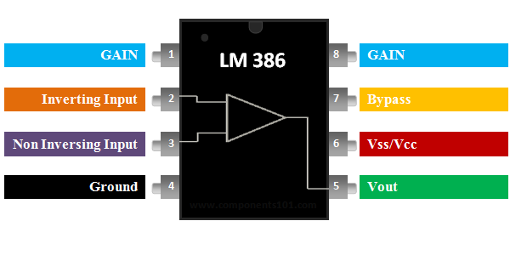

Fig 2

Some important **features of the LM386**:

**PIN 1 and 8: These are the PINs for gain control. Internally, the gain is set to 20, but can be increased to 200 with a capacitor between PIN 1 and 8. We used the 10uF C3 capacitor to get the highest gain, 200 The gain can be set to any value between 20 and 200 using a suitable capacitor.**

**Pin 2 and 3: These are the input PIN codes for the audio signals. Pin 2 is the negative input connector that is connected to ground. Pin 3 is the positive input connector to which the audio signal is sent for amplification. In our circuit it is connected to the positive pole of the condenser microphone with a 100k RV1 potentiometer. The potentiometer serves as a volume control.**

## Pins 4 and 6: These are the IC power supply pins, pin 6 is + VDC and pin 4 is ground. The circuit can be supplied with a voltage between 5 and 12 V.

## Pin 5: This is the output PIN code from which we get the amplified sound signal. It is connected to the loudspeaker via a capacitor C2 in order to filter the noise injected in the direct current.

## Pin 7: This is the bypass connection. For additional stability, it can be left open or grounded with a capacitor

## Pin diagram and description

|  |  |  |
| --- | --- | --- |
| **Pin** | **Name** | **Purpose** |
| 1 | GAIN | Used to adjust the gain of the IC by connecting it to a capacitor |
| 2 | INVERTING INPUT | The amplifier's reverse pin is usually grounded |
| 3 | NON INVERTING INPUT | The non-inverting pin is supplied with the audio signal |
| 4 | GROUND | The ground pin is connected to the system ground |
| 5 | VOUT | Offers an amplified audio output that is connected to the speaker |
| 6 | Vss/Vcc | Connected to the power supply |
| 7 | BYPASS | The bypass pin is used to connect a decoupling capacitor |
| 8 | *GAIN* | Used to adjust the gain of the IC by connecting it to a capacitor |

**The LM386 is a low power audio frequency amplifier that is commonly used in small audio amplifiers. The integrated circuit uses very little energy and can therefore be used with a 9 V battery without any problems. An 8-ohm loudspeaker with variable gain from 20 to 200 can be easily controlled. In this regard, volume controls and gain controls are also possible. The integrated circuit is supplied in an 8-pin PDIP housing and requires very few components for operation, making it very easy to use.**

**So if you are looking for an audio amplifier IC that can be powered by a battery for a portable application to drive an 8 ohm speaker, this IC may be the right choice for you. To drive heavy speakers, you need to use the power amplifier ICs.**

**The LM386 requires only a few capacitors and resistors to start operating. A very basic LM386 circuit that is commonly used is shown below**

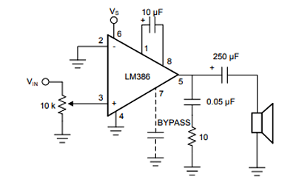

**The integrated circuit is supplied via pin 6 (generally 5 or 9 V) and the ground pin 4 is connected to ground. The inverting pin (pin 2) is normally grounded and the non-inverting pin (pin 3) is supplied with the audio signal. This audio signal can come from a microphone or even from a 3.5mm jack. The 10k resistor is added in series with the audio signal to serve as a volume control. You can ignore this potentiometer if you want to work at full volume.**

**Pin 1 and Pin 8 are used to adjust the gain of the amplifier. If nothing is connected between these pins, the standard gain is 26 dB. However, we can connect a 10 uF capacitor to get the maximum integrated circuit gain of 46 dB.**

**Pin 7 is used to connect a filter capacitor (0.1 uf) for our amplifier IC to avoid unnecessary vibrations. The amplified audio signal can be obtained from pin 5, which is connected to an 8 ohm speaker via a filter capacitor. The RC network with 0.05 uF and a resistance of 10 k is optional.**

**2D MODEL FOR LM386**

**Gsnnanaegnt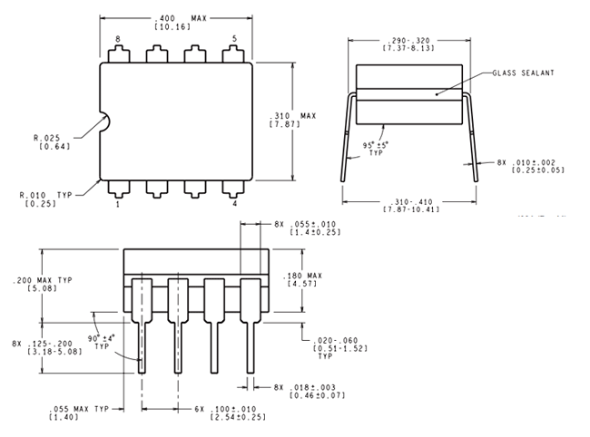 SPEAKER:**

**The four main types of speakers that can be found in the household today are conventional speakers, wall / ceiling speakers, sound bars and subwoofers. Each type of speaker has a different purpose and is useful for different applications. Speaker. ... Regardless of their design, the purpose of the speakers is to produce audio that can be heard by the listener. Loudspeakers are transducers that convert electromagnetic waves into sound waves. The speakers receive audio input from a device such as a computer or an audio receiver.**

**Fig 3**

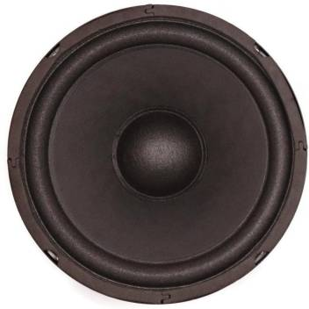

**Photo Diode:**

**A photodiode is a semiconductor device that converts light into electrical current. Current is generated when photons are absorbed in the photodiode. Photodiodes can contain optical filters and integrated lenses and can have large or small areas. Photodiodes generally have a slower response time as their surface area increases. The traditional and usual solar cell for generating electrical solar energy is a large-area photodiode.**

**Photodiodes are similar to common semiconductor diodes, except that they can either be exposed (to detect UV or X-rays under vacuum) or packed with a window or fiber optic link to allow light to pass through. '' you can reach the sensitive part of the device. Many diodes designed for special use as a photodiode use a PIN junction instead of a pn junction to increase the response speed. A photodiode is designed for operation in reverse polarization. A photodiode is a pn junction or a PIN structure. When a photon hits the diode with sufficient energy, it creates an electron-hole pair. This mechanism is also known as the internal photoelectric effect. If the absorption occurs in the depletion region of the transition or at a diffusion distance from it, these carriers are washed away from the transition by the integrated electric field of the depletion region. Thus the holes move towards the anode and the electrons towards the cathode, and a photocurrent is generated. The total current through the photodiode is the sum of the dark current (current generated in the absence of light) and the photocurrent. Therefore, the dark current must be minimized to maximize the sensitivity of the device.**

**In the first order, the photocurrent is linearly proportional to the irradiance for a given spectral distribution.**

**Materials commonly used to manufacture photodiodes include**

**MATERIALS ELECTROMAGNETIC SPECTRUM**

**SILICON 190 - 1100**

**GERMANIUM 400 - 1700**

**INDIUM GALIUM ARSENIDE 800 - 2600**

**LEAD SULFIDE <1000 - 3500**

**MERCURY TELLURIDE 400 – 14000**

**Fig 4**

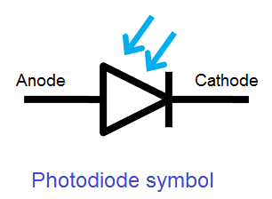

**Transistor** :

**There are typically three electrical leads in a transistor, called the emitter, the collector, and the base. An electrical signal applied to the base (or gate) influences the semiconductor material’s ability to conduct electrical current, which flows between the emitter and collector in most applications. A voltage source such as a battery drives the current, while the rate of current flow through the transistor at any given moment.**

* **Driver Modules like Relay Driver, LED driver**
* **Amplifier modules like Audio amplifiers, signal Amplifier**

**Fig 5**

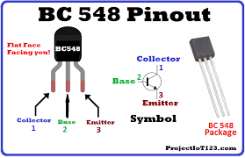

**Earlier, the critical and important component of an electronic device was a vacuum tube; it is an electron tube used to** [**control electric current**](https://www.edgefxkits.com/smooth-start-of-a-single-phase-induction-motor)**. The vacuum tubes worked but they are bulky, require higher operating voltages, high power consumption, yield lower efficiency and cathode electron-emitting materials are used up in operation. So, that ended up as heat which shortened the life of the tube itself. To overcome these problems, John Bardeen, Walter Brattain and William Shockley were invented a transistor at Bell Labs in the year of 1947. This new device was a much more elegant solution to overcome many of the fundamental limitations of vacuum tubes.**

**Transistor is a semiconductor device that can both conduct and insulate. A transistor can act as a switch and an amplifier. It converts audio waves into electronic waves and resistor, controlling electronic current. Transistors have very long life, smaller in size, can operate on lower voltage supplies for greater safety and required no filament current. The first transistor was fabricated with germanium. A transistor performs the same function as a vacuum tube triode, but using semiconductor junctions instead of heated electrodes in a vacuum chamber. It is the fundamental building block of modern electronic devices and found everywhere in modern electronic systems.**

### Transistor Basics:

**A transistor is a three terminal device. Namely,**

* **Base: This is responsible for activating the transistor.**
* **Collector: This is the positive lead.**
* **Emitter: This is the negative lead**

NPN transistor

**N-P-N transistor consisting a layer of P-doped semiconductor between two layers of N-doped material. By amplifying current the base we get the high collector and emitter current.**

**That is when NPN transistor is ON when its base is pulled low relative to the emitter. When the transistor is in ON state, current flow is in between the collector and emitter of the transistor. Based on minority carriers in P-type region the electrons moving from emitter to collector. It allows the greater current and faster operation; because of this reason most bipolar transistors used today are NPN.**

**CAPACITORS:**

***A capacitor is a device that stores electrical energy in an electrical field. It is a passive electronic component with two connections.***

***The effect of a capacitor is known as a capacitor. Although there is some capacitance between two nearby electrical conductors in a circuit, a capacitor is a component designed to add capacitance to a circuit. The capacitor was originally known as a capacitor.This name and its relatives are still widely used in many languages, but only rarely in English, with the exception of condenser microphones, also called condenser microphones.***

***The physical shape and construction of practical capacitors vary widely, and many types of capacitors are commonly used. Most capacitors contain at least two electrical conductors, often in the form of metal plates or surfaces that are separated by a dielectric medium. A conductor can be a foil, a thin film, a sintered metal bead or an electrolyte. The non-conductive dielectric increases the charging capacity of the capacitor. Materials commonly used as dielectrics include layers of glass, ceramic, plastic, paper, mica, air, and oxide. Capacitors are often used as parts of electrical circuits in many common electrical devices. Unlike a resistor, an ideal capacitor does not consume energy, although the actual capacitors consume a small amount. (See Not Ideal Behavior).When an electrical potential, a voltage, is applied to a capacitor, such as when a capacitor is connected through a battery, the dielectric creates an electrical field that causes the net to collect a positive charge on a plate and a net negative charge to be collected on the other plate. No current actually flows through the dielectric. However, there is a charge flow through the source circuit. If the state is maintained long enough, the current flowing through the source circuit ceases. When a time-varying voltage is applied to the capacitor, the source experiences DC current due to the capacitor's charge and discharge cycles.***

***The first forms of capacitors were made in the 1740s when European experimenters discovered that the electrical charge could be stored in glasses filled with water, known as Leyden glasses. In 1748, Benjamin Franklin combined a series of pots to create a so-called "electric battery" that optically differs from a cannon battery that has become the standard English term for electric battery. Nowadays, capacitors are often used in electronic circuits to block direct current while allowing alternating current to pass through. In analog filter networks, they smooth the output of the power supplies. In resonant circuits, they tune the radios to specific frequencies. They stabilize the voltage and energy flow in electrical energy transmission systems. The property of energy storage in capacitors was used in the first digital computers as dynamic storage.***

**Fig 6**

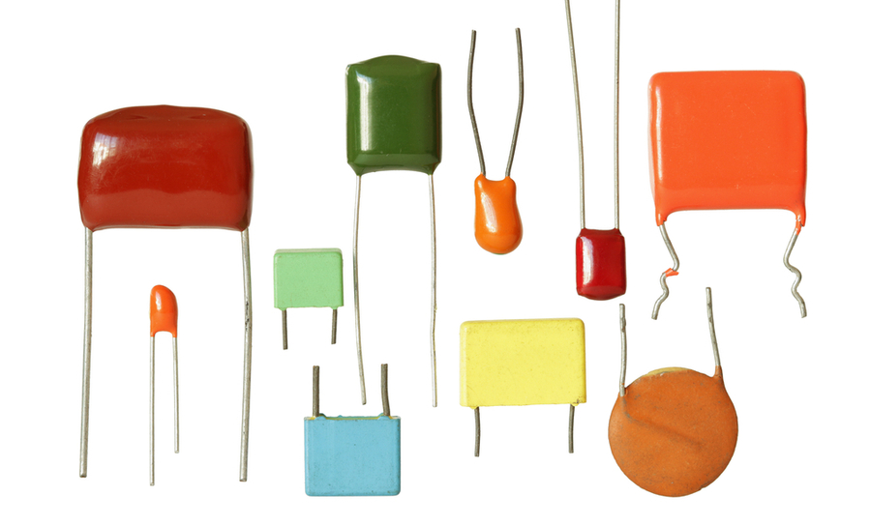

**POWER SUPPLY:**

**A power supply is a device that supplies electric power to a electric load .The term is most commonly referred to electric power converts that converts one form of electrical energy to another ,though it may also refer to that convert another form of energy ( mechanical chemical, solar) to electrical energy . The regulated power supply is that controls the output voltage or current to a specific value ;the controlled value is held nearly .**

**Fig 7**

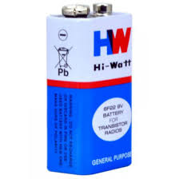

RjadVKLnb’RPNBalkrnVaLKVAL.WGNRVLqnghqrilhgQEIJGQp’;gjQP’EIGR’P;INGAQNRPVG;INAWNVINAR

**BREADBOARD:**

**A breadboard is a solderless device for temporary prototype with electronics and test circuit designs. Most electronic components in electronic circuits can be interconnected by inserting their leads or terminals into the holes and then making connections through wires where appropriate.**

**Fig 8**

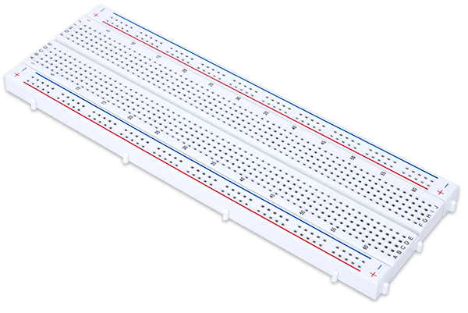

IR TRANAMITTER:

**An IR emitter contains an LED that emits infrared light. Therefore the name. The receiver contains either a photodiode or a phototransistor (usually the latter). Depending on the amount of IR light falling on it, this component allows more or less current to pass through. The LED lights up and off in a coded order.**

**Fig9:**

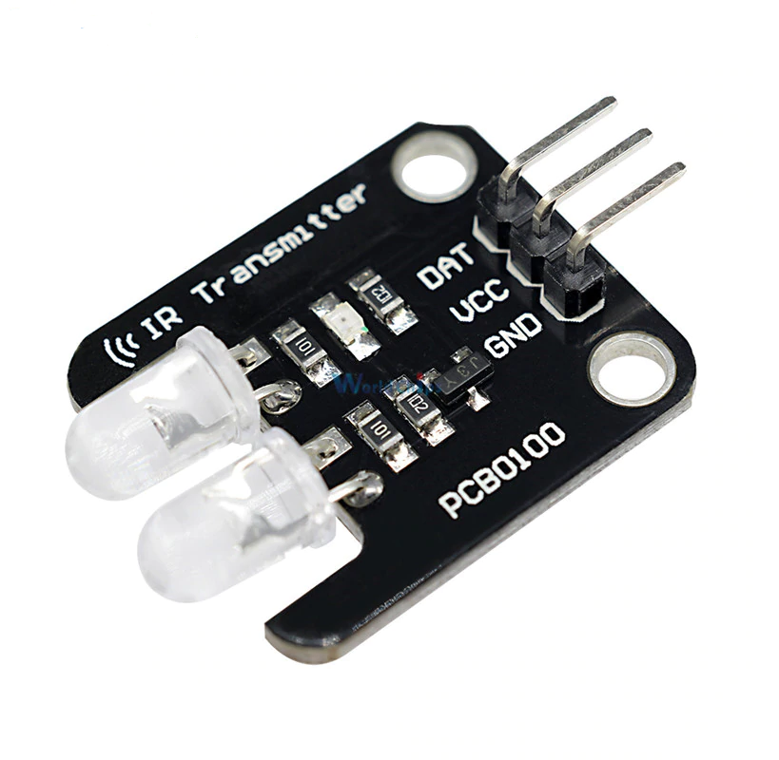

POTENTIOMETER:

**A potentiometer is a three-pole resistor with a sliding or rotating contact that forms an adjustable voltage divider.If only two connections are used, one end and the wiper, it acts as a variable resistor or rheostat.**

**The measuring device referred to as a potentiometer is essentially a voltage divider with which the electrical potential (voltage) is measured. The component is an implementation of the same principle, hence the name.**

**Potentiometers are commonly used to control electrical devices such as volume controls on audio devices. Potentiometers that are operated by a mechanism can be used as position transducers, for example in a joystick. Potentiometers are rarely used to directly control significant power (more than one watt) because the power consumed in the potentiometer would be comparable to the power in the controlled load.**

**Fig10:**

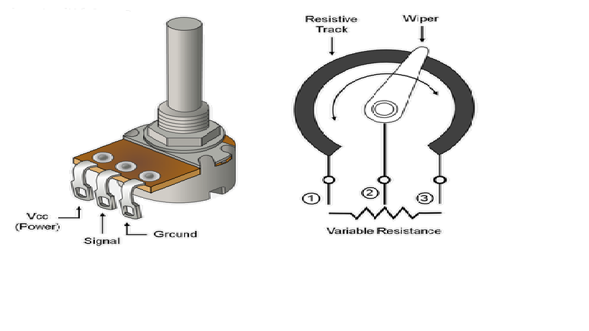

**RESULT**

**The project works successfully. Whenever we connect it to the audio.**

**Fig11:**

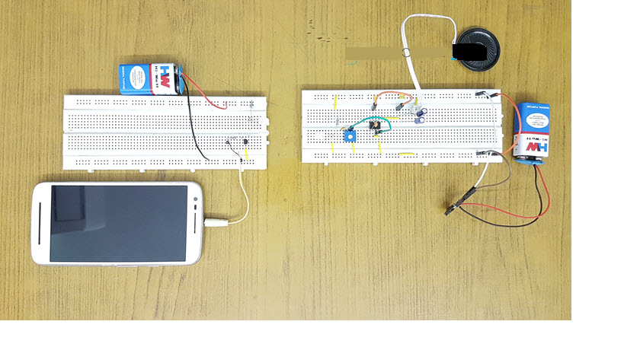

**CHAPTER 6**

**CONCLUSION AND FUTURE SCOPE**

**The main principle of this circuit is IR communication. Infrared (IR) is only used for line of sight over a short range. In the electromagnetic spectrum, infrared rays are rays whose wavelengths are longer than the wavelengths of visible light. These infrared rays are not visible to the human eye, but we can see these IR rays through the digital camera.**

**A typical infrared communication system includes an infrared source such as infrared lasers or LEDs with specific wavelengths. The transmission media used for infrared communication are vacuum, atmosphere and optical fibers. Finally, we will use photodiodes or phototransistors in IR communication to detect IR rays.**

**The output signal from these detectors is very weak and may not be able to drive the speakers. Therefore we will use a simple amplifier to amplify the signal. This amplified signal can potentially drive the speakers.**

***In future we can extend the distances between the IR transmitter and recicer, We can also control multiple number of devices at one time, And also the data transfer rate can be incresed upto 4MBPS.***

**REFERENCES**

Grob’s Basic Electronics

<https://www.electronicshub.org/simple-ir-audio-link-circuit/>

<https://circuitdigest.com/electronic-circuits/ir-based-wireless-audio-transmitter-and-receiver-circuit-diagram>

<https://www.instructables.com/id/IR-Based-Wireless-Audio-Transmitter-and-Receiver/>

<https://www.electronicsforu.com/electronics-projects/hardware-diy/ir-transmitter-receiver>

<https://akindiaprojects.blogspot.com/2019/05/Ir-transmitter-and-recever.html?showComment=1557080725774>

<https://www.pinterest.com/pin/467600373807622069/>